THE SENIOR MANAGEMENT STRUCTURE OF EWRYOCA CAN BE OUTLINED AS FOLLOWS:

1. Ayan Nejib Aden Executive Director



2. Mohamed Ahmed

Finance Head/Director



3. Yusra Nasir Hassen

Program Head

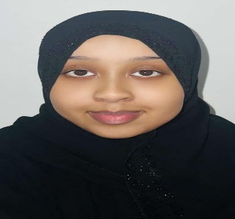

4. ssudiin anes yusuf

Director of HR & Administration



5. Ayaan Aden Siraj: Monitoring & Evaluation (M&E) Head –

